# Plotting some graphs to check Analytical Question

In [24]:

**import** seaborn **as** sns

sns.barplot(data**=**df, x**=**df['Job Type'],y**=**df['Initial Cost'])

Out[24]:

<AxesSubplot:xlabel='Job Type', ylabel='Initial Cost'>

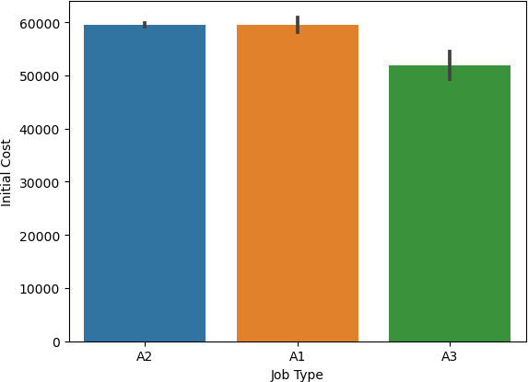

In [26]:

sns.distplot(df['Community - Board'].value_counts())

plt.show()

C:\Users\HP\anaconda3\lib\site-packages\seaborn\distributions.py:2619: Fut ureWarning: `distplot` is a deprecated function and will be removed in a f uture version. Please adapt your code to use either `displot` (a figure-le vel function with similar flexibility) or `histplot` (an axes-level functi on for histograms).

warnings.warn(msg, FutureWarning)

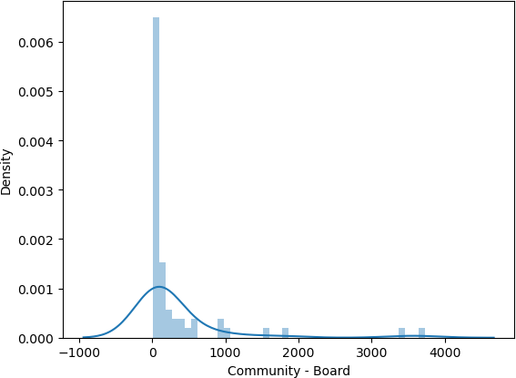

In [28]:

sns.pairplot(df)

plt.show()

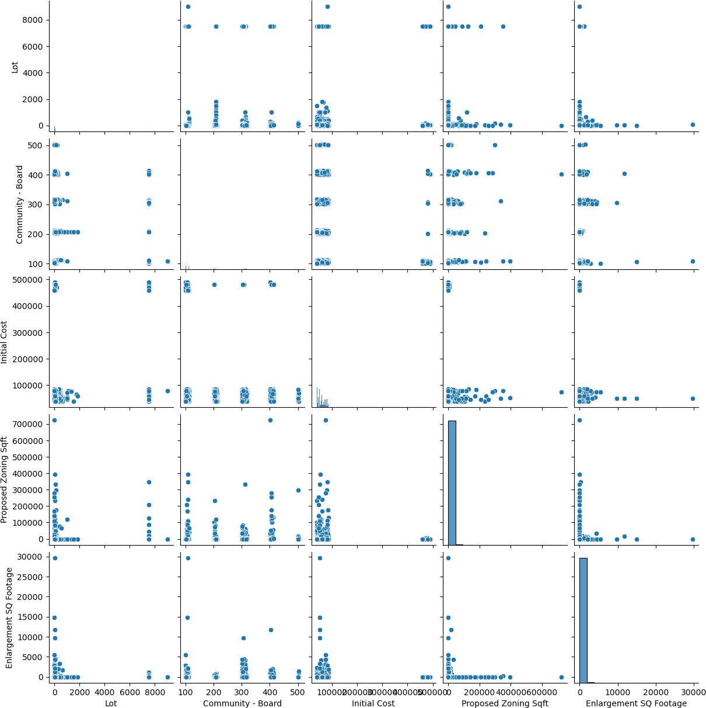In [ ]: